W368R-How to limit the computers’ download and upload speed?

Product line: Wireless Question category: Function configurations

Q：Why do we need to limit the computer’s download and upload speed?
A：In the LAN, multi computers share the same network. If someone download or view the video streams, it will influence others. So you can limit the computer’s download rate through setting Traffic Control.

The Steps are as below:
1. Login to the router’s home page.
2. Click Advanced Settings→Bandwidth Control and tick the Enable Bandwidth Control to enable it.
For example, we want to limit the maximum upload rate of the computer with IP address 192.168.0.100 to be 30KBytes. Please do following the picture as below.
Note: 1Mbps=128KBytes, 2Mbps=256Kbytes

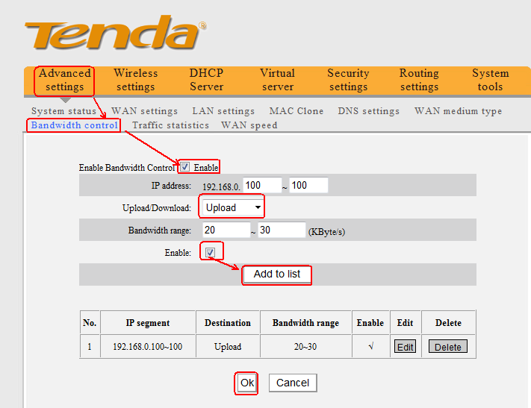

For example, we want to limit the maximum download rate of the computer with IP address 192.168.0.100 to be 100KBytes. Please do following the picture as below.
Note: 1Mbps=128KBytes, 2Mbps=256Kbytes

